|  |  |
| --- | --- |
| **Canon RF 85mm f/2 Macro IS STM Lens**  Ống kính Canon RF 85mm f/2 Macro IS STM    canon rf 85mm f2 macro IS STM Lens-4 canon rf 85mm f2 macro IS STM Lens-1 canon rf 85mm f2 macro IS STM Lens-1 canon rf 85mm f2 macro IS STM Lens-2 | **Featured information:**   * FullFrame/RF-Mounts Lens format * Maximum magnification: 1:2 * Closest focusing distance: 35.05cm * UD lens   Price : 500$  **Specifications:**   * **Focal distance:** 85mm * **Largest Aperture:** f/2 * **Smallest Aperture:** 0 * **Lens Mount:** RF * **Lens Format:** Full-Frame * **View:** 28° * **Minimum Focus Distance:** 35.05 cm * **Magnification:** 0.5 * **Optical Components:** 12 Elements in 9 Groups * **Number of Mouth Blades:** 9 * **Focus Type:** Auto focus * **Anti-Vibration:** Yes * **Filter Size:** 67 mm * **Size:** 78 x 90.5 mm * **Weight:** 500 g |

**Description:**

#### **Highlights of the Canon RF 85mm f/2 Macro IS STM lens**

Portrait prime lens designed for use with Canon RF FullFrame mirrorless cameras. Compact f/2 maximum aperture helps maintain a pleasing overall appearance while also benefiting working in available light conditions. The macro design is beneficial when working with close-up subjects and provides a maximum magnification of 1:2 at a minimum focusing distance of 35cm. Optical image stabilization reduces shake by up to 5 stops to enable better working in low light conditions and slow shutter speeds. The Hybrid IS setting compensates for angular movements and shift patterns that are especially beneficial for close-up shooting. The STM stepping focus motor delivers fast, smooth, precise, and quiet AF performance that is ideal for video or still photography.



STM stepping motor delivers quiet, smooth AF performance and full-time manual focus. To produce sharp images, this lens also features optical image stabilization along with Hybrid IS that can reduce camera shake by up to 5 stops for clearer and steadier shots.

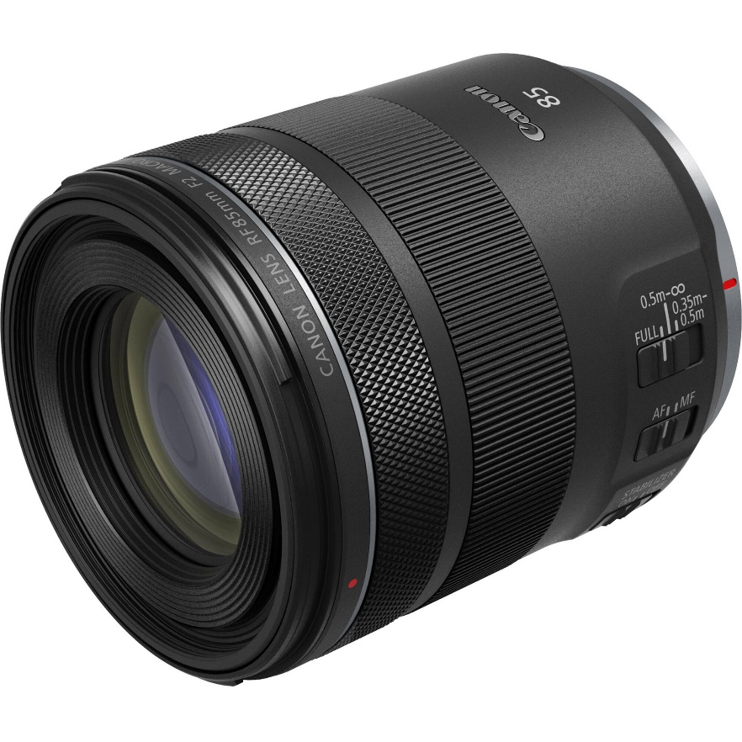

Additionally, UD (Ultra low Dispersion) lenses are also used in the optical design to reduce aberrations and ensure clarity. Additionally, a configurable control ring lets you adjust exposure settings including ISO, aperture, and exposure compensation from the lens itself.